PT LAPI GANESHA UTAMA
In technical partnership with the Institute of Technology Bandung

TECHNICAL CERTIFICATION DOCUMENT

IECEx/ATEX Certification Document
Gas Leak Detector (GLD) V2
Prepared in direct reference to the IECEx/ATEX Certification Information Requirements issued by the certification body (ExCB) — covering all three sections of that checklist: Section 1, Basic Information (Application and Organization); Section 2, Technical Documentation (Items 1–6: product description; name, model, and specification list; functional description and technical parameters; product photographs; intended use and installation environment; and design and manufacturing information); and Section 3, Sample Information.
Document Control
Document title | IECEx/ATEX Certification Document — Gas Leak Detector (GLD) V2
Document no. | LGU/GLD/IECEX-TDF/2026-001
Revision | 1.2
Date | 28 September 2026
Status | Working Document — Draft for Internal Review
Classification | Confidential — prepared for ATEX/IECEx certification body (ExCB) submission
Certification subject | Node Sensor (GLD) — V2
Manufacturer | PT Galaksi Megatama Indonesia
Design & development authority | PT LAPI Ganesha Utama
Technical partner | Institute of Technology Bandung
Reference checklist | IECEx/ATEX Certification Information Requirements

Revision History
REVISION | DATE | DESCRIPTION
0.1 | 11 September 2026 | Initial issue — Section 2 (Items 1–6) and Section 3.
0.2 | 17 September 2026 | Section 1, Basic Information (Application and Organization), added — Items 1.1–1.5. Document now covers all three sections of the checklist.
0.3 | 22 September 2026 | Manufacturer-of-record for Section 1 changed to PT Galaksi Megatama Indonesia (legal documents on file); PT LAPI Ganesha Utama recorded as design and development authority. Section 2.6.g draft content (safety warnings, installation procedures, operating modes, commissioning equipment) added.
0.4 | 22 September 2026 | Candidate enclosure component data (ADC12 die-cast alloy, M20×1.5 cable entry, electrostatic-safety parameters) added to Sections 2.3.c, 2.6.a, and 2.6.c, sourced from a supplier reference drawing in the casing partner's supply chain.
0.5 | 22 September 2026 | Enclosure material grade confirmed as ADC12 (Section 2.3.c, status raised to Final with an explicit caveat that this extrapolates from the casing manufacturer's sub-component drawing, not a direct callout on the main enclosure drawing). Cable entry (Section 2.3.c) confirmed as a 2-conductor cable labeled L+/L−, each conductor ≈0.75 mm diameter.
0.6 | 22 September 2026 | Total weight corrected to 2.3 kg; IP rating confirmed as IP66; operating humidity confirmed as 10–90% RH non-condensing (standard industrial rating, matched to a comparable certified product); cable gland confirmed as M20×1.5 (IP66-rated) — all raised to Final (Section 2.3.c). Removed the ambiguous “no plastic or PVC” parenthetical from the product description (Section 2.1) and generalized “L-bracket” to “bracket” in that same narrative sentence (the dimensioned bracket/U-bolt specification in Section 2.3.c is unaffected). “GLD V2 (Version 2)” simplified to “GLD V2”.
0.7 | 22 September 2026 | “L-bracket” terminology corrected throughout to “U-bolt mounting plate” (Sections 2.1, 2.3.c, 2.6.g), matching the actual CAD drawing (a flat 250×250 mm plate secured by 2× U-bolts — not an angled/L-shaped bracket).
0.8 | 24 September 2026 | Total weight, operating temperature, and operating humidity (Sections 2.3.c, 2.5) updated to 2.378 kg, −20°C to +60°C, and 5–95% RH respectively, per current project specification data.
0.9 | 25 September 2026 | Section 2.6.c (material specification sheets, non-metallic materials) expanded with the specific IEC 60079-0 requirements (CTI class, glow-wire/flame-retardancy, Tg vs. the confirmed operating range, UV/weathering resistance) and a list of the non-metallic components in GLD's own design that this item will need to cover (sensor mesh/flame-arrestor cover, cover-to-body sealing gasket, cable-gland seal, antenna feedthrough insulator); status remains Not yet available pending the casing partner's data.
1.0 | 25 September 2026 | Section 2.6.c updated with materials confirmed from a newer casing-partner assembly drawing: the protective mesh cover is stainless steel (metallic, outside the scope of this non-metallic-materials item) and the cover-to-body seal is a rubber gasket (compound/grade still not specified).
1.1 | 25 September 2026 | Added an explicit equipment-boundary statement to Section 2.3.a: the Node Sensor (GLD) receives only 24 VDC at its terminal and never carries 220 VAC internally; the AC/DC adapter is a separate, site-supplied device outside the certified unit's physical boundary. Section 2.6.c cable-gland seal remark clarified as specified together with the M20×1.5 gland itself from the BP18-1Z reference, per project direction, rather than as a separately sourced item.
1.2 | 28 September 2026 | Type of protection narrowed to a single team recommendation, Ex d (flameproof enclosure), in Sections 1.1 and 2.5 — selected over Ex e and Ex i based on the existing ADC12 die-cast enclosure with a stainless-steel mesh flame path (matching the three certified reference products reviewed) and the MQ-sensor heaters' continuous, unregulated power draw being difficult to reconcile with intrinsically safe energy limits for Group IIC. Section 2.6.e updated accordingly. Still an internal recommendation, not an ExCB decision.

Table of Contents
About This Document 5
1. Basic Information (Application and Organization) 5
1.0 · Status Summary — Section 1 6
1.1 · Application Form 6
1.2 · Business License / Company Registration Certificate 7
1.3 · Organizational Chart and Contact Information 8
1.4 · Manufacturing Plant Address and Introduction of Production Facilities 9
1.5 · ISO 9001 Certificate, Quality Manual, and Procedure Index 10
2. Technical Documentation 11
2.1 · Detailed Product Description 11
2.2 · Product Name, Model, and Specification List 11
2.3 · Functional Description and Technical Parameters (Electrical, Mechanical, etc.) 12
2.3.a · Electrical Parameters — Node Sensor (GLD) 12
2.3.b · Sensor and Communication Parameters — Node Sensor (GLD) 13
2.3.c · Mechanical Parameters — Node Sensor (GLD) 15
2.4 · Product Photographs — Overall and Key Components 18
2.5 · Description of Intended Use and Installation Environment (Gas Group, Temperature Class, Area Classification) 19
2.6 · Design and Manufacturing Information 21
2.6.a · Complete Drawings (Assembly, Component, Electrical Schematic, PCB Layout, Enclosure Structure, Junction Box, Terminal, Grounding) 21
2.6.b · Bill of Materials (BOM) for Explosion-Safety-Relevant Components 28
2.6.c · Material Specification Sheets / Datasheets (Non-Metallic Materials) 32
2.6.d · Manufacturing Process Description 32
2.6.e · Explosion-Protection Calculations and Explanations (if applicable) 32
2.6.f · Temperature Group Calculation (Hottest-Point Temperature Estimation) 33
2.6.g · Usage and Installation Instructions (Draft) 33
2.6.h · Nameplate Information 34
2.6.i · Ex Component Certificates 35
3. Sample Information 35
3.1 · Model, Serial Number, and Status 35
3.2 · Test Fixtures and Auxiliary Equipment 35

About This Document
This document is a working technical file prepared against the official IECEx/ATEX Certification Information Requirements checklist issued by the certification body (ExCB). It follows that checklist section by section: “1. Basic Information (Application and Organization)”, “2. Technical Documentation”, and “3. Sample Information”. Section 1 is administrative: it sets out every particular the ExCB requires and states which are already confirmed and which remain to be supplied from corporate records, without entering assumed values.
Scope of this document. This is a compilation of design evidence and an honest readiness assessment against the ExCB checklist, prepared in support of a future submission — it is not itself a certificate and does not constitute self-certification. The final enclosure/casing (material selection, manufacture, gasket, and cable entry) is being developed by an external mechanical/casing partner (PT Galaksi Megatama Indonesia — legal identity confirmed, Section 1.4) and is not yet in the authors' possession; items that depend on that design (material datasheets, manufacturing process description, explosion-protection calculations) are reported as not yet available for that reason, not because the work has stalled. The product is still at from-scratch development/prototype stage — no finalized, serialized units exist yet, which is why a formal sample register (Section 3.1) is not yet available either.

Original excerpt, Section 2 & 3 — source: IECEx ATEX Certification Information Requirements (ExCB):
“1) Detailed product description; 2) Product name, model, and specification list; 3) Complete and clear functional description and technical parameters (electrical parameters, mechanical parameters, etc.); 4) Clear product photos (overall and key components); 5) Description of intended use and installation environment (e.g., gas group IIC/IIB/IIA if applicable, temperature group T1–T6, ambient temperature range, area classification 0/1/2 or 20/21/22); 6) Design and manufacturing information [a–i: drawings, BOM, material datasheets, manufacturing process, explosion-protection calculations, temperature group calculation, usage and installation instructions, nameplate information, Ex component certificates]. 3. Sample Information: 1) model, serial number, and status of the sample; 2) necessary test fixtures or auxiliary equipment.”

1. Basic Information (Application and Organization)
Five items per the original checklist: the application form, the business license/company registration certificate, the organizational chart and contact information, the manufacturing plant address and production-facility profile, and — where applicable — the ISO 9001 certificate together with the quality manual and procedure index.
How this section is presented. The items below are administrative rather than technical: they are satisfied by corporate records held by the manufacturer's legal and administrative functions, not by engineering output. Every required field is therefore set out in full so that it can be collected in a single pass, with its current status stated plainly. No field has been filled with an assumed or placeholder value.

Manufacturer-of-record for this section: PT Galaksi Megatama Indonesia. This section reports the legal/corporate particulars of PT Galaksi Megatama Indonesia as the Manufacturer named in the ExCB application, since it holds the Indonesian industrial manufacturing business license (NIB) relevant to fabricating the equipment (KBLI 25119/25120/28221/25920 — metal products, pressurized-vessel-class containers, metalworking machinery, and special metal-treatment services). PT LAPI Ganesha Utama (LGU) is the design and development authority responsible for the electronics, firmware, and system engineering of the GLD, working with the Institute of Technology Bandung as technical partner; it is recorded as such throughout Sections 2 and 3. This attribution reflects a working decision recorded 22 September 2026 based on PT Galaksi's legal documents (deed of establishment, NIB, NPWP, MOLHR ratification decree, tax registration certificate) supplied to the authors — it has not yet been confirmed directly with either company's officers as the final arrangement for the ExCB submission and should be verified before formal filing.

Original excerpt, Section 1 — source: IECEx ATEX Certification Information Requirements (ExCB):
“1. Basic Information (Application and Organization): 1) Application form (provided by ExCB as a template). 2) Manufacturer's business license/company registration certificate. 3) Manufacturer's organizational chart and contact information. 4) Address of manufacturing plant and brief introduction of production facilities. 5) (If applicable) ISO 9001 certificate, quality manual, and directory of procedure documents (for QAR/QAN review).”

1.0 · Status Summary — Section 1
ITEM | STATUS | HELD BY
1.1 Application form (ExCB template) | Template not yet received | Issued by the ExCB
1.2 Business license / company registration | Partially available | Manufacturer (PT Galaksi Megatama Indonesia) — legal documents now on file; a few particulars still open
1.3 Organizational chart and contact information | Partially available | Manufacturer — Board of Directors/Commissioners names known from the deed; a full org chart and named ExCB contacts remain to be provided
1.4 Manufacturing plant address and facility profile | Partially available | Manufacturer's registered office and production-site addresses now on file; floor profile, process capability, and quality system still pending
1.5 ISO 9001 certificate, quality manual, procedure index | To be confirmed | Manufacturer — quality function

1.1 · Application Form
The application form is issued by the certification body as a template and has not yet been received; it is therefore not reproduced here. The information needed to complete it, however, is already consolidated in this document, and is restated below in the order an application form normally requests it so that transcription is a single step once the template arrives.
APPLICATION FIELD | VALUE | STATUS | REFERENCE
Applicant / manufacturer | PT Galaksi Megatama Indonesia | Confirmed | Section 1.2
Design and development authority | PT LAPI Ganesha Utama (LGU) | Confirmed
Technical development partner | Institute of Technology Bandung — IoT Laboratory & Physics Laboratory | Confirmed
Product name | Gas Leak Detector (GLD) — Node Sensor | Confirmed | Section 2.2
Model / version | GLD V2 | Confirmed | Section 2.2
Scope of certification | Node Sensor (GLD) only | Confirmed | Section 2.1
Requested area classification | Zone 1, Equipment Category 2G, Group II | Requested — subject to ExCB assessment | Section 2.5
Requested temperature class | T4 (≤135 °C) | Target — verification outstanding | Sections 2.5, 2.6.f
Requested gas group | IIC | Internal recommendation, not an ExCB decision | Section 2.5
Type of protection | Ex d — flameproof enclosure | Internal recommendation, not an ExCB decision | Section 2.5
Standards to be applied | IEC 60079-0, together with IEC 60079-1 (flameproof enclosures “d”) | Dependent on the item above | Section 2.6.e
Certification route requested | IECEx Certificate of Conformity and/or ATEX EU-type examination | To be confirmed with the ExCB
Intended markets | To be provided | To be provided

The three requested classification parameters above are the applicant's proposal. They are recorded here as a request, not as an agreed or granted classification.

1.2 · Business License / Company Registration Certificate
REQUIRED PARTICULAR | STATUS | REMARKS
Registered legal name | Available | PT Galaksi Megatama Indonesia.
Legal form and shareholding status | Available | Perseroan Terbatas (limited liability company), National Private / PMDN (domestic investment), Small Enterprise scale. Deed No. 52 (22 Sep 2022, Notary Steffi Alphanie, S.H., M.Kn., Cilegon City): President Director Nur Rohman (2,250 shares), Director Antonius Prasetyo (2,625 shares), Commissioner Crisa Andi Sujatmiko (2,625 shares); authorized capital Rp300,000,000, paid-up Rp75,000,000.
Business registration number | Available | NIB (Business Identification Number) 0510220020593, issued 5 Oct 2022 under Indonesia's risk-based business licensing (OSS) system.
Taxpayer identification number | Available | NPWP 61.126.496.1-427.000 (16-digit: 0611264961427000), Tax Service Office of Pratama West Bekasi, registered 29 Sep 2022.
Deed of establishment and latest amendment | Partially available | Deed of Establishment No. 52 dated 22 Sep 2022, ratified by Ministry of Law and Human Rights Decree No. AHU-0067398.AH.01.01.Year 2022 (29 Sep 2022, Company Register No. AHU-0194149.AH.01.11.Year 2022). No subsequent amendment deed has been supplied; whether one exists is unconfirmed.
Registered (domicile) address | Available | Plaza Summarecon Bekasi, Jl. Bulevar Ahmad Yani Kav. K.01, Level 7, Harapanmulya Village, Medansatria Sub-district, Bekasi City, West Java, Postal Code 17143.
Scope of business activity relevant to this product | Partially available | NIB lists KBLI 25119 (other prefabricated metal products for construction), 25120 (tanks, reservoirs and containers of metal – explicitly including pressurized gas cylinders), 28221 (machinery/machine tools for metalworking), and 25920 (special metal-treatment industrial services), among others, at production sites in Cikarang Selatan and Mustikajaya, Bekasi. This is a general metal-fabrication license; it does not by itself constitute an Ex-specific manufacturing qualification.
Scanned certificate, with English translation where requested | Available | NIB, NPWP, Deed of Establishment, MOLHR ratification decree, and Certificate of Registration (SKT) are on file with sworn English translations (Fikri Said Obed, S.S., Sworn Translator, Jakarta, 19 Sep 2026). Notarization/legalization requirements for ExCB submission to be confirmed.

1.3 · Organizational Chart and Contact Information
REQUIRED PARTICULAR | STATUS | REMARKS
Organizational chart | Partially available | Statutory Board of Directors/Commissioners known from the deed of establishment (below); a functional chart showing the units responsible for design, production, and quality, and the reporting line between them, has not been provided.
Board of Directors and Board of Commissioners | Available | President Director: Nur Rohman. Director: Antonius Prasetyo. Commissioner: Crisa Andi Sujatmiko. (Deed No. 52, 22 Sep 2022.)
Authorized signatory for the application | To be confirmed | The President Director (Nur Rohman) is the statutory officer entitled to represent the company (Articles of Association, Art. 12.5.a); whether he is the specific individual who will sign the ExCB application is not yet confirmed.
Certification project contact | To be provided | Name, position, e-mail, and telephone — the single point of contact for ExCB correspondence.
Technical contact for the product | To be provided | The engineer who will answer technical queries on the technical file.
Quality contact | To be provided | Counterpart for the quality assessment referred to in 1.5.
Technical partner contact | Organization identified; contact to be confirmed | Institute of Technology Bandung — IoT Laboratory / Physics Laboratory.
Correspondence address and working language | To be provided | English is assumed for correspondence with the ExCB unless stated otherwise.

1.4 · Manufacturing Plant Address and Introduction of Production Facilities
The Manufacturer's registered office and NIB-listed production-site addresses are now on file (below). Facility floor profile, process capability, and quality-system detail are not yet documented. The product is at prototype stage, and the specific location where serial units will be produced has not been fixed — this is stated as a fact of the current development phase, not as an omission from the file.
PRODUCTION ELEMENT | STATUS | REMARKS
Manufacturer's registered office and production sites | Available | PT Galaksi Megatama Indonesia — registered office: Plaza Summarecon Bekasi, Jl. Bulevar Ahmad Yani Kav. K.01, Level 7, Bekasi City, West Java. NIB-registered production sites: Jl. Kp. Jatipilar, Cikarang Selatan, Bekasi Regency; and Jl. WR Supratman, Mustikajaya, Bekasi City. NIB lists metalworking KBLI including 25120 (Manufacture of Tanks, Reservoirs and Containers of Metal – explicitly covers pressurized gas cylinders), 25119, 28221 (metalworking machinery), and 25920 (special metal-treatment services). This confirms a licensed general metal-fabrication business — it is not an Ex-certified enclosure manufacturer license, and no ISO 9001 or Ex-specific quality certificate has been supplied.
Printed circuit board fabrication and assembly | Partially available | The electronic design is maintained by LGU as a native EasyEDA/JLCPCB project and the component supply chain is referenced to LCSC supplier part numbers throughout the bill of materials (Section 2.6.b). The fabrication and assembly provider, and its address, remain to be confirmed in writing.
Enclosure / casing manufacture | Partially available | Enclosure development and manufacture sits with the Manufacturer, PT Galaksi Megatama Indonesia (identity and registered addresses above). Plant floor profile, process capability, and Ex-specific process controls remain to be provided (see remaining rows below and Sections 2.6.c/2.6.d).
Final assembly, configuration, and functional test | Prototype stage | Currently carried out in the development laboratory environment. The production location for serial units has not been fixed.
Production facility profile | To be provided | Floor area, principal equipment, staffing, and nominal throughput — the “brief introduction” requested by the checklist.
Incoming inspection and final quality control | To be provided | Arrangements for verifying purchased components and finished units.
Ex-specific routine verification | To be provided | Routine tests and verifications required of production units once a type of protection is selected.

Where any stage of serial manufacture is subcontracted, certification bodies normally expect each manufacturing location covered by the quality assessment to be identified by name and address. The final list of locations therefore depends on the production arrangement adopted after the prototype stage.

1.5 · ISO 9001 Certificate, Quality Manual, and Procedure Index
REQUIRED PARTICULAR | STATUS | REMARKS
ISO 9001 certificate | To be confirmed | Whether the manufacturer currently holds certification and, if so, the certificate number, scope, issuing body, and validity period.
Quality manual | To be provided
Index of procedure documents | To be provided | A directory is sufficient at this stage; individual procedures are normally requested during the assessment itself.
Documented control of Ex-relevant characteristics | To be provided | How drawings, changes, and the characteristics that secure the type of protection are controlled in production.
Records of routine verification | To be provided | Record format for the routine tests referred to in 1.4.

Note on the quality requirement. The checklist marks this item “if applicable” and links it to quality assessment review. Under both schemes a manufacturer is expected to demonstrate a quality system covering Ex production before certificates are issued — through an IECEx Quality Assessment Report, or through the corresponding production-quality or product-verification arrangement under ATEX — whether or not ISO 9001 certification is held. The route that applies to this application is to be confirmed with the ExCB; ISO 9001 certification, where held, generally shortens that assessment rather than replacing it.

2. Technical Documentation
Six items per the original checklist (1–6, with Item 6 comprising sub-items a–i). This revision addresses the complete section: Items 1–6.

2.1 · Detailed Product Description
The Gas Leak Detector (GLD) is an IoT-based, multi-sensor gas leak detection device designed for the early detection of flammable and process gases in oil & gas refinery environments (process units, tank farms, pipe racks, and storage/loading-unloading areas). This document addresses the GLD unit itself as the subject of the current IECEx/ATEX certification.
Functionally, the GLD integrates eight channels of metal-oxide semiconductor gas sensors (MQ series), an edge-AI microcontroller/processor (ESP32-S3), and a LoRa radio module (star-topology wireless transmission) within a single fixed-point unit installed at locations with gas-leak risk. An on-device AI gas-classification model runs directly on the unit so that detection decisions do not depend on a continuous connection to a central server. When gas concentration exceeds a defined threshold, the unit triggers a local alarm (an integrated visual/audible alarm module) and simultaneously transmits an alarm notification over the LoRa network to the operator dashboard.
The enclosure is designed for hazardous-area deployment at refinery sites, using metal materials (aluminum alloy and stainless steel) and mounted via a U-bolt mounting plate to existing structures without drilling or welding. Important: this design-intent statement does not constitute a claim that the enclosure has passed testing or has been Ex-certified — the explosion-protection scheme, gas group, temperature class, and target installation zone will be addressed in Section 2.5.
The current production power configuration is continuous 24 VDC, supplied via an AC/DC adapter connected to the site electrical supply. A portable battery power path (Li-ion 18650) remains under development (R&D) and has not become a deployed production configuration.

2.2 · Product Name, Model, and Specification List
Product name | Gas Leak Detector (GLD) — Node Sensor
Model / version | GLD V2
Manufacturer | PT Galaksi Megatama Indonesia
Design & development authority | PT LAPI Ganesha Utama (LGU)
Technical development partner | Institute of Technology Bandung — IoT Laboratory & Physics Laboratory
End client / program owner | PT Pertamina Patra Niaga (initial deployment site: Refinery Unit IV, Cilacap)
Primary function | Acquisition of 8-channel gas sensor data and LoRa transmission
Microcontroller | ESP32-S3-WROOM-1U-N16R8
LoRa radio module | E22-900MM22S
Dimensions (L×W×H) | 200 × 90 × 290 mm
Enclosure material | Aluminum alloy (ADC12 die-cast) + stainless steel

Source: official product technical datasheet (Institute of Technology Bandung, Revision 4.0), cross-referenced with internal technical specification documentation and EMC parameter measurement data.

2.3 · Functional Description and Technical Parameters (Electrical, Mechanical, etc.)
Functional workflow (normal operating mode): sense → process → transmit. Each of the eight gas sensors continuously samples ambient conditions → data is normalized and classified by the on-device AI model (ESP32-S3) → the result is transmitted over the LoRa network (star-topology transmission) at a configurable interval (default 10 seconds), or immediately (event-driven) when an alarm condition is detected. Gas alarms are triggered through two parallel channels: a local visual/audible alarm module on the unit itself, and a push notification transmitted over the LoRa network to the dashboard — the alarm-push pathway has been successfully tested on a campus mesh network (field validation at a production refinery installation is still pending).

2.3.a · Electrical Parameters — Node Sensor (GLD)
PARAMETER | SPECIFICATION | STATUS | REMARKS
Main power input | 24 VDC | Final — production config. | Continuous power supply from a site AC/DC adapter.
AC/DC adapter input | 220 VAC, 50 Hz | Final | Compliant with the Indonesian national electrical grid standard (PLN).
AC/DC adapter output | 24 VDC | Final
Internal operating voltage | 5 VDC & 3.3 VDC | Final | 5 VDC for the MQ sensor/heater circuitry; 3.3 VDC for ESP32-S3 logic. Per-rail current not yet documented separately.
Equipment boundary (mains exposure) | None — 24 VDC only | Final | The Node Sensor (GLD) itself receives only 24 VDC at its terminal and never carries 220 VAC internally. The AC/DC adapter (220 VAC/50 Hz → 24 VDC) is a separate, site-supplied device outside the physical boundary of the certified unit; its own installation location (e.g., relative to the hazardous-area zone) is a site electrical-design matter, not a parameter of this equipment.
Maximum input current | ≈0.33 A @ 24 VDC | Calculated | Calculated from measured maximum power consumption (7.995 W) divided by 24 VDC.
Maximum power consumption | 7.995 W @ 24 VDC | Measured — production config. | Applies to the continuous-power configuration. The battery (R&D) configuration is recorded separately at 5.75 W — a different operating mode, not a data conflict.
Electrical protection (fuse, reverse polarity, overvoltage, overcurrent) | 2× resettable PPTC fuse (F1/F2); TVS/ESD suppression diodes (D1, D4/D5/D11, D6); Schottky diodes (D7/D13, D8/D9, D12) | Partially available — component-level evidence | Real components exist per the EasyEDA/JLCPCB bill of materials (Section 2.6.b): 2× Littelfuse MINISMDC260F/16 resettable fuses (F1, F2, overcurrent), a Ruilong SMBJ33A TVS diode (D1) and 3× UMW LESD5D5.0CT1G / 1× DOWO SM712 ESD-protection arrays (D4, D5, D11, D6), and multiple Schottky diodes — MDD SS54 (D7, D13), MDD SS14 (D8, D9), GOOD-ARK SK36 (D12). This is genuine evidence that overcurrent and transient/ESD protection circuitry exists on the board; which specific rail each component protects and its exact circuit role (e.g., reverse-polarity blocking vs. flyback) has not yet been cross-checked against the schematic net list, and no consolidated protection-scheme write-up has been produced for ExCB review.

2.3.b · Sensor and Communication Parameters — Node Sensor (GLD)
PARAMETER | SPECIFICATION | STATUS | REMARKS
Gas sensors | MQ-2, MQ-3B, MQ-4, MQ-5, MQ-6, MQ-7B, MQ-8, MQ-135 (8 channels) | Final | Metal-oxide semiconductor sensors; sensing element directly exposed to ambient air.
AI gas-classification model | On-device classifier — 3 classes: Clean Air, LPG, H₂ | Final | Runs locally on the ESP32-S3 (Running/Inference mode); outputs a class label and a confidence value. Does not yet cover CO₂, Benzene, CO, or H₂S.
Environmental sensor (temperature/humidity) | SHT40-AD1B-R2 (I2C) | Final | Auxiliary temperature/humidity input included in the primary hardware design; values are available for status/telemetry.
Analog-to-digital converter | ADS1256IDBR | Final | 24-bit multi-channel analog acquisition for the 8 sensor channels; 30,000 SPS, firmware SPI clock 1.92 MHz.
Processing unit | ESP32-S3-WROOM-1U-N16R8 | Final | Certified under FCC (2AC7Z-ESPS3WROOM1U), TELEC, and CE (per Espressif data) — RF/EMC certifications, not an “Ex component” certification.
Communication module | LoRa, E22-900MM22S module | Final | Certified under CE, FCC, and RoHS (per Ebyte data) — RF/EMC certifications, not an “Ex component” certification.
Operating frequency | 920 MHz | Final | Star-topology transmission; within the regional 920–923 MHz ISM band (Indonesia).
Transmit power (firmware configuration) | 17 dBm | Final | The radio module supports up to 22 dBm — 17 dBm is an operational configuration, not the module's maximum limit.
Bandwidth / spreading factor / coding rate | 125 kHz / SF7 / CR 4/5 | Final | Source: EMC parameter table and official product technical datasheet.
Antenna | External, omnidirectional, SMA male connector, 3 dBi gain | Final | On some units, the 2.4 GHz Wi-Fi antenna remains inside the enclosure and must be relocated externally.
Data transmission interval | Configurable, default 10 seconds | Final | Alarm events are transmitted immediately, independent of the periodic interval.
Other interfaces | SPI, LoRa | Final | External ports/connectors: USB, sensor, power, fan, antenna, alarm buzzer.
RS-485 / Modbus interface | Read-only Modbus RTU slave, 9600 bit/s 8N1, Unit ID 1 (THVD1410DR transceiver) | Final | Provides 8 read-only registers (device status word, classification result, confidence, battery voltage, power source, external power, LoRa transmission counter, node ID); not used for product control.

2.3.c · Mechanical Parameters — Node Sensor (GLD)
PARAMETER | SPECIFICATION | STATUS | REMARKS
Enclosure material | Aluminum alloy (ADC12 die-cast) + stainless steel | Final | Per project confirmation, the production enclosure is sourced from a commercially available CE/ATEX-marketed explosion-proof gas-detector housing product line (referenced supplier listing: Alibaba.com, “CE ATEX Explosion Proof H2 Sensor”), consistent with the cast-metal housing, threaded “Ex”-marked cable entry, and sensor mesh cover shown in the product photography (Section 2.4). This is corroborated by an internal case CAD drawing (“GLD ATEX CASE v3,” dated 8 September 2026) specifying a cylindrical sensor-case body (Ø102 mm outer housing ring, Ø90/Ø80 mm internal bores) that incorporates a stainless-steel filter mesh disc, a small DC cooling fan, and a transparent viewing window. PVC is not used in any housing or bracket component. Alloy grade — ADC12: the enclosure metal is die-cast aluminum grade ADC12 (a standard, widely used die-cast aluminum alloy), per project confirmation. Caveat on how this grade was established: ADC12 is the material called out on a Chinese enclosure-component manufacturer's drawing for a related die-cast sub-component (“Universal Base,” part no. BP18-1Z, from the same casing-partner supply chain — see Section 2.6.a); the “GLD ATEX CASE v3” drawing of the main enclosure body itself does not carry its own material callout. The project has confirmed ADC12 as the enclosure grade on the basis that the same casing manufacturer's die-cast product line uses this alloy consistently — this is an extrapolation from the supplier's sub-component drawing, not a direct material callout on the main enclosure drawing, and should be verified against the casing partner's own datasheet for the enclosure body before formal ExCB submission.
Dimensions (L × W × H) | 200 × 90 × 290 mm | Final | Consistent between the technical specification documentation and the EMC parameter table.
Total weight | 2.378 kg | Final | Total weight of PCB, casing, and sensors combined; project-confirmed value, not yet documented against a calibrated weighing record.
Mounting method | U-bolt mounting plate, following the design already installed at the refinery | Final | Mounted to existing structures without drilling or welding.
Ingress protection (IP rating) | IP66 | Final | Project-confirmed value; not yet independently tested/verified against IEC 60529.
Cable entry (gland) | M20×1.5 cable gland (IP66-rated); power cable is 2-conductor, labeled L+/L− (positive/negative of the 24 VDC supply), each conductor ≈0.75 mm diameter | Final | Conductor count and per-conductor wire diameter confirmed by the project. Gland thread size (M20×1.5) is selected by engineering judgment to match the BP18-1Z reference drawing from the same casing-manufacturer supply chain (Section 2.6.a) — a standard, IP66-rated gland size well suited to this conductor count/diameter, not an independent gland datasheet or fit test on GLD's own enclosure. Overall cable outer diameter and insulation rating remain to be documented.
Antenna mounting | External, SMA male connector | Final
Operating temperature | −20°C to +60°C (ambient) | Final | Project-confirmed value — a key input for temperature class (T1–T6) determination in Section 2.5. Not yet documented against a calibrated test record.
Operating humidity | 5–95% RH, non-condensing | Final | Project-confirmed value. Not yet documented against a calibrated test record.

Source: internal technical specification documentation, Sections 1.1–1.3 (Node Sensor), cross-referenced with the official product technical datasheet (Revision 4.0) and component certification verification (ESP32-S3-WROOM-1U, E22-900MM22S).
Rows marked “Pending confirmation” above do not reflect a documentation oversight — this is an honest status indicator. These fields are intentionally left blank because no official data yet exists (not yet measured, tested, or decided). They must not be filled with estimates in future revisions without a clear supporting data source.

2.4 · Product Photographs — Overall and Key Components
The seven photographs below were taken directly from the Node Sensor (GLD) V2 prototype unit (no capture-date metadata is available in the source files). The first three photographs show the fully assembled unit from different angles; the remaining four show key components in close-up.
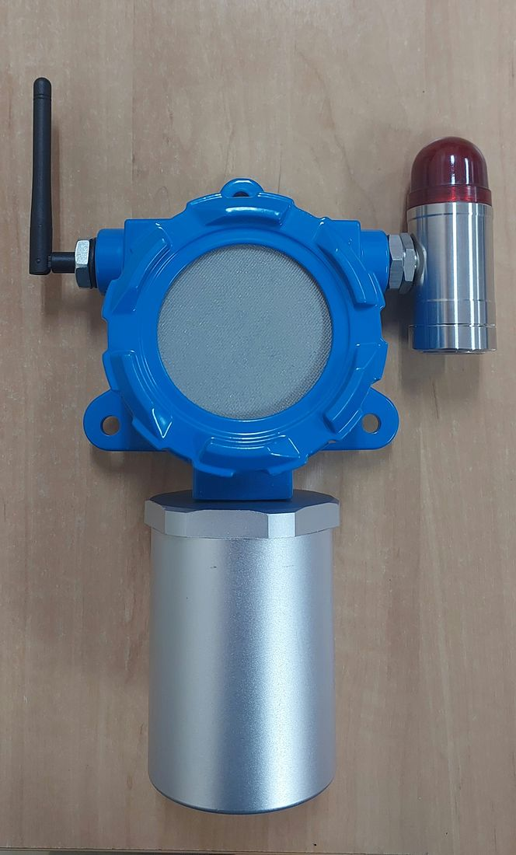  Complete unit — front view  The fully assembled Node Sensor (GLD): the main enclosure (blue) with sensor mesh cover, external LoRa antenna, and a visual alarm module (cylindrical housing, red lens) mounted on the right side. | 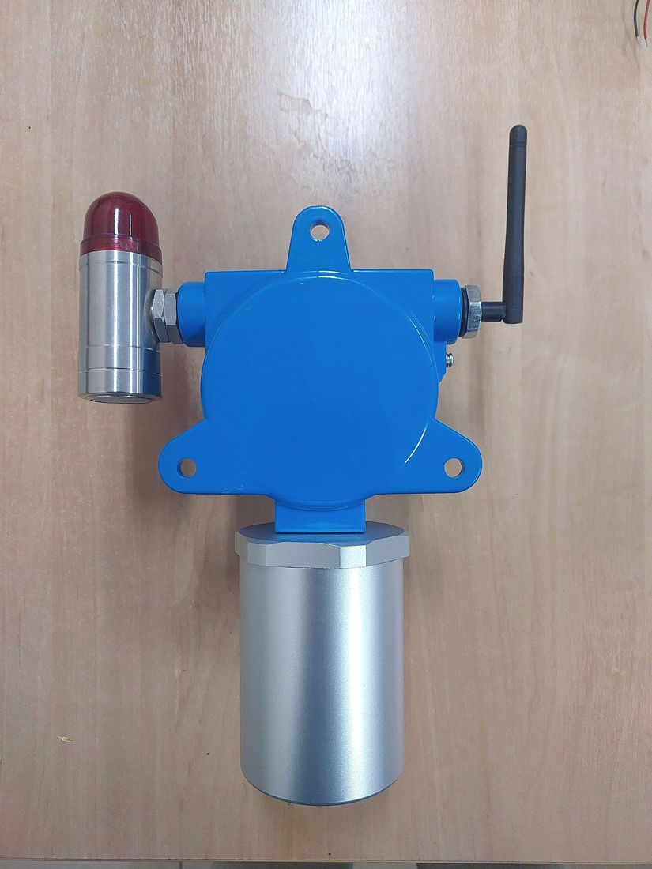  Complete unit — alternate angle  An alternate view of the assembled unit, showing the position of the antenna, alarm module, and the cable-gland side of the enclosure.
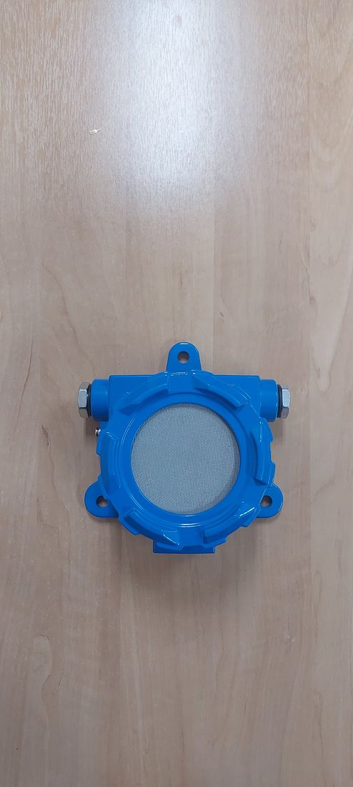  Complete unit — front view (without antenna and alarm module)  The main enclosure with the sensor mesh cover installed, shown in a flat front view illustrating the enclosure shape and its four mounting bolt holes. | 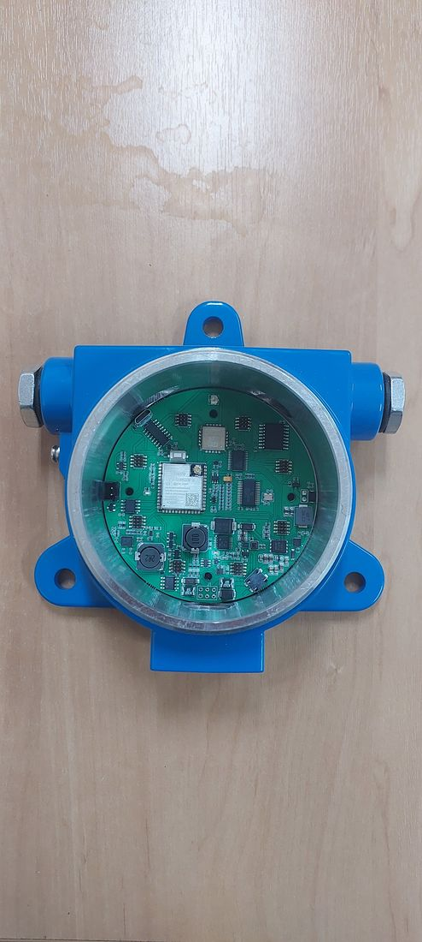  Key component — PCB inside enclosure (before sensor modules)  The main PCB installed inside the enclosure prior to gas sensor module installation. The ESP32-S3-WROOM-1U microcontroller, LoRa radio module, and power circuitry are visible.
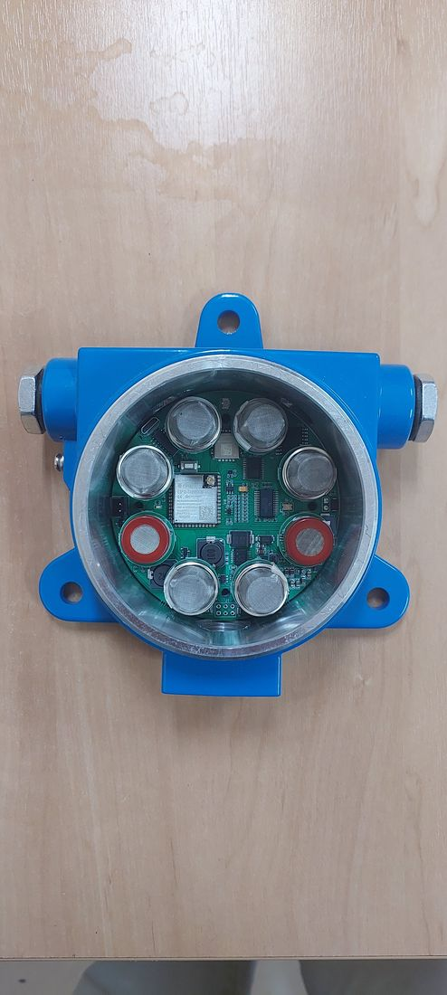  Key component — PCB with eight gas sensor modules  The same PCB with eight channels of MQ-series gas sensors (MQ-2, MQ-3B, MQ-4, MQ-5, MQ-6, MQ-7B, MQ-8, MQ-135) installed around the central microcontroller. | 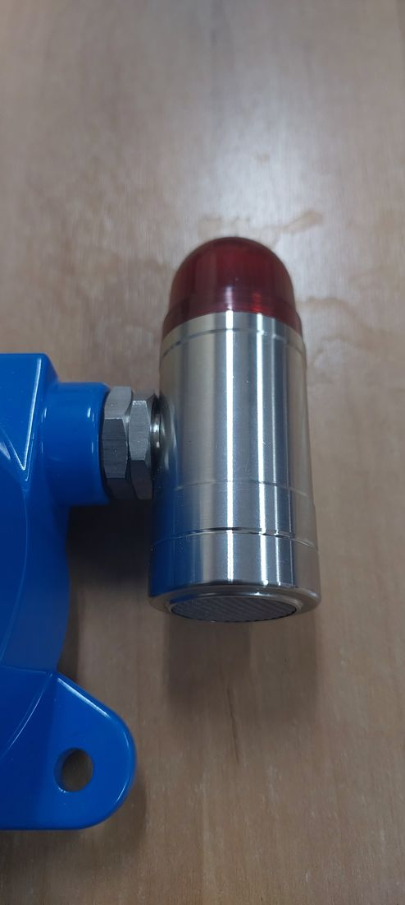  Key component — visual alarm module (close-up)  The visual alarm (beacon/strobe) module, constructed of metal with a red lens, connected to the main enclosure via a dedicated cable gland.
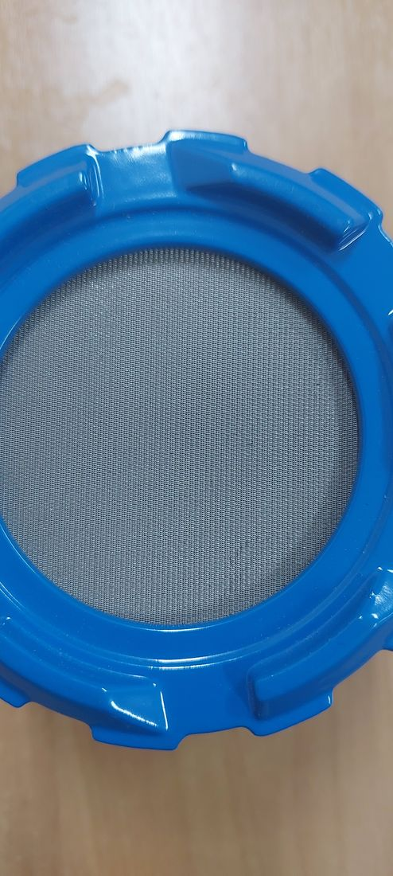
Key component — sensor mesh cover (close-up)
The metal mesh cover that protects the gas sensing elements while serving as a diffusion path for gas to reach the sensors beneath.

Photographic completeness — status as-is. The seven photographs above cover the complete unit and its key components (PCB, sensor modules, alarm module, mesh cover), substantively satisfying checklist Item 2.4. Still outstanding: (a) formally labeled photographs of each face (front/back/left/right/top/bottom) with a scale reference, as is customary in ExCB submission packages; (b) separate photographs of individual components such as the battery, gaskets/seals, terminals, and cable glands.

2.5 · Description of Intended Use and Installation Environment (Gas Group, Temperature Class, Area Classification)
The GLD is intended for continuous, fixed-point monitoring of flammable and toxic gas leaks in oil & gas refinery hazardous areas — process units, tank farms, pipe racks, and loading/unloading areas. The specific Ex classification parameters below reflect the project engineering team's current recommendation, developed from the intended deployment envelope and the gases the device is designed to detect; none of these parameters has yet been confirmed with the certification body (ExCB) or a notified body, and none should be treated as final.
PARAMETER | RECOMMENDED VALUE | STATUS | RATIONALE / REMARKS
Gas group | IIC | Team recommendation — pending ExCB confirmation | Hydrogen (H₂) is one of the three gases the classifier is designed to detect (Section 2.3.b); IIC is required for hydrogen and inherently covers IIB and IIA.
Temperature class | T4 (≤135°C) | Team recommendation — pending verification | Not yet substantiated by measurement. MQ-series metal-oxide sensors rely on an internal heating element as their normal operating principle; a hot-spot measurement specific to the sensor models and enclosure configuration used here has not yet been performed (see 2.6.f).
Ambient temperature range | −20°C to +60°C | Final | Project-confirmed value, consistent with the Mechanical Parameters table (Section 2.3.c). Distinct from the MQ-sensor hot-spot surface temperature above, which remains the top-priority open item for the T4 recommendation.
Area classification (zone) | Zone 1 | Team recommendation — pending ExCB confirmation | Assessed as sufficient for the general refinery deployment envelope, including areas near storage. Zone 0 would only apply if the detector were installed directly inside a tank vapor space.
Type of protection | Ex d — flameproof enclosure | Team recommendation — pending ExCB confirmation | Selected over Ex e and Ex i based on the existing enclosure design: a die-cast aluminum (ADC12) housing with a stainless-steel wire mesh over the sensing element functions as a flame path/flame arrestor, the same pattern used by the three comparable certified gas detectors reviewed as references (all Ex d). Ex i was set aside because the MQ-series sensor heaters draw continuous power (≈0.75 W each) directly from an unregulated 24 VDC supply rather than through certified current-limiting barriers, difficult to reconcile with intrinsically-safe energy limits for Group IIC. Ex e was not pursued because it is not intended for enclosures with normally-energized, potentially arcing parts such as the sensor heaters.

These are engineering recommendations, not a certification decision. An independent readiness assessment of the same checklist item, prepared separately from the underlying firmware/hardware repository, reached the same conclusion — gas group, temperature class, ambient range, zone, and type of protection are not yet formally established. Final classification requires explicit agreement with the ExCB.

2.6 · Design and Manufacturing Information
Nine sub-items (a–i) per the original checklist. Status is reported item by item below; most sub-items are not yet available — this is reported plainly rather than implied to be complete.

2.6.a · Complete Drawings (Assembly, Component, Electrical Schematic, PCB Layout, Enclosure Structure, Junction Box, Terminal, Grounding)
An electrical schematic capture and a corresponding PCB layout exist for the GLD V2 main board as native EasyEDA/JLCPCB source design files (not just a derived summary). From the schematic's traced net list, a supporting block-diagram set (9 sheets, functional/block level, 204 components mapped with documented pin-to-net traceability) has been produced and is reproduced in full below. Field labels in the source diagrams are in Indonesian; English captions are provided under each sheet.
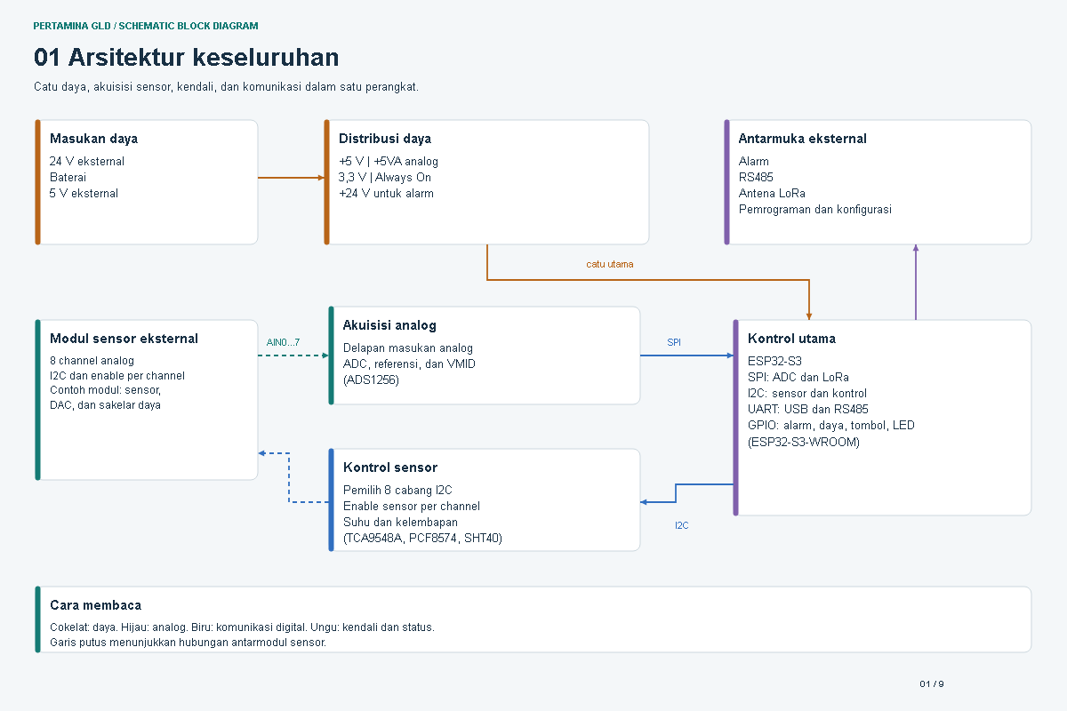
Sheet 1 of 9 — Overall architecture
Power input, power distribution, analog acquisition, sensor control, main control (ESP32-S3), and external interfaces (alarm, RS-485, LoRa antenna, programming/configuration).
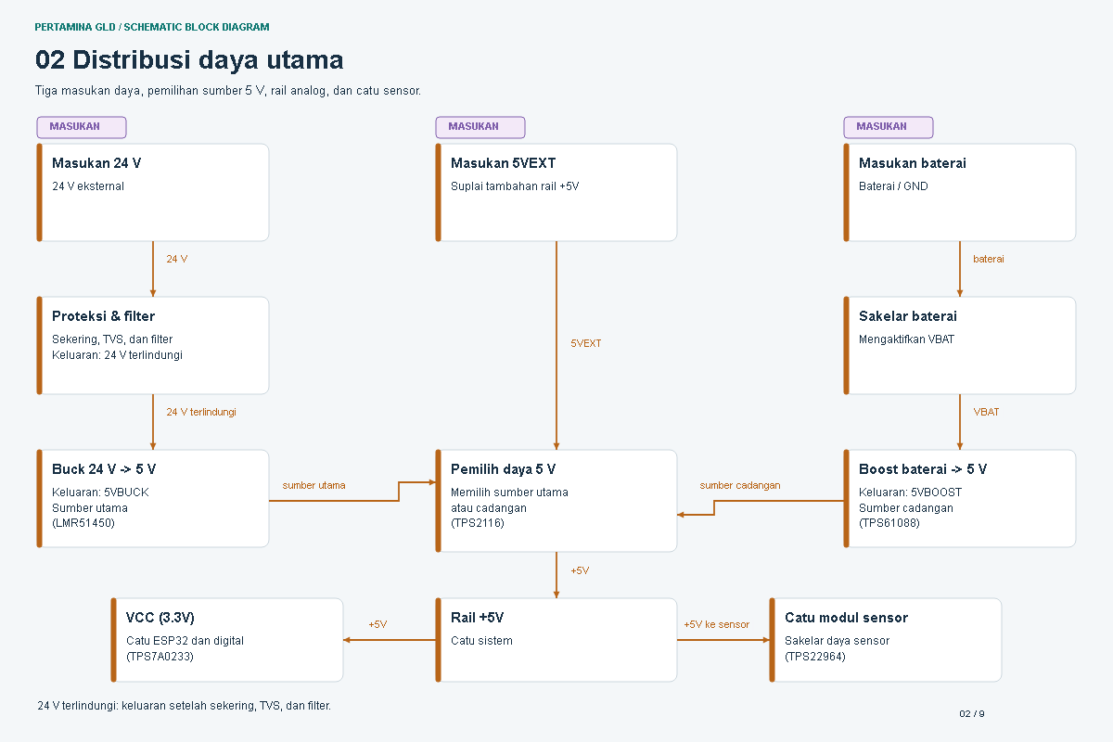
Sheet 2 of 9 — Main power
Main power input rails and distribution: +5 V / +5VA analog, 3.3 V, and +24 V for the alarm circuit.
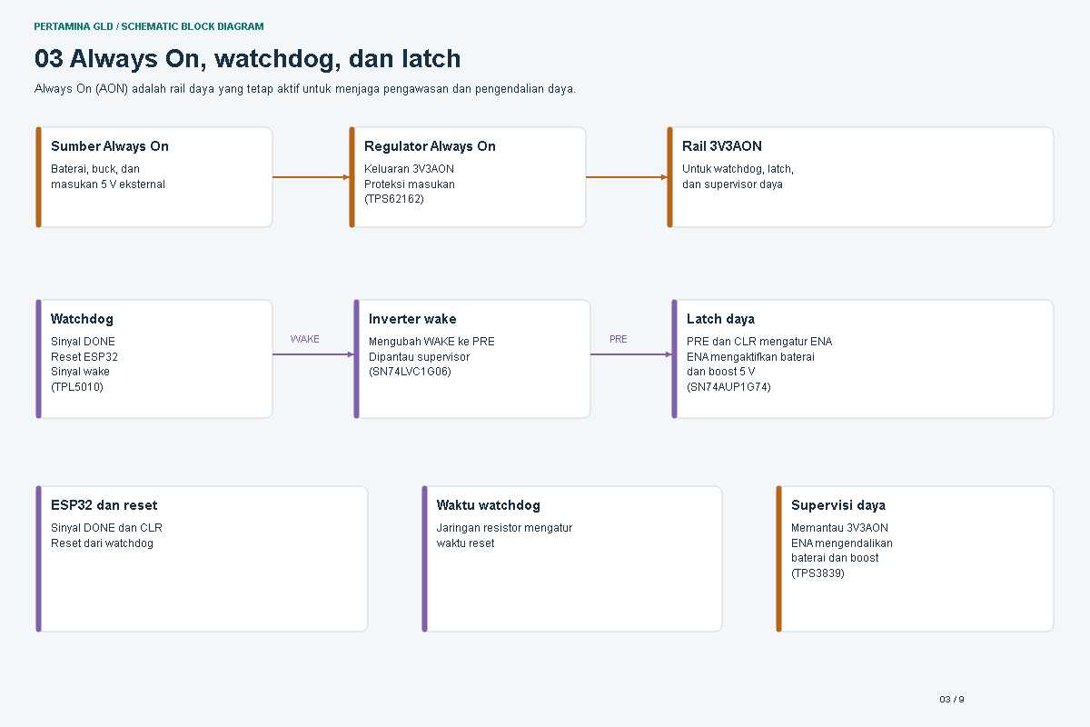
Sheet 3 of 9 — Always-on power
The always-on power domain that remains active independent of the main control state.
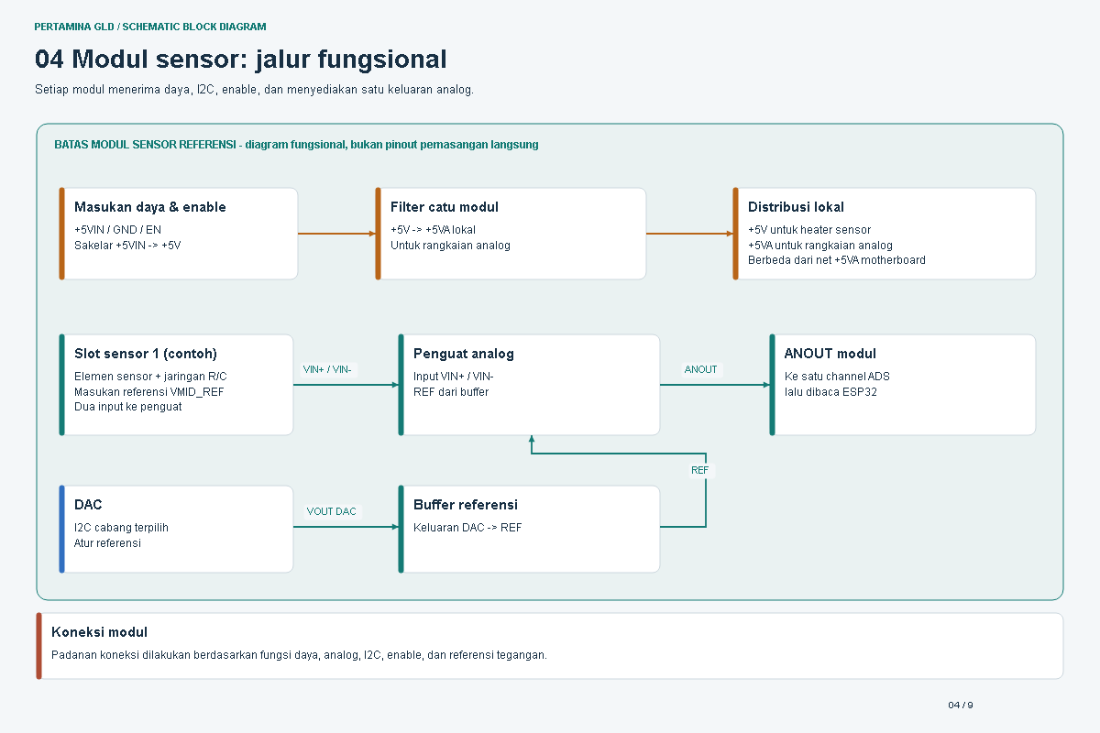
Sheet 4 of 9 — Sensor module
The external gas sensor module: 8 analog channels with per-channel I2C enable, including the sensor, DAC, and power-switch sub-blocks.
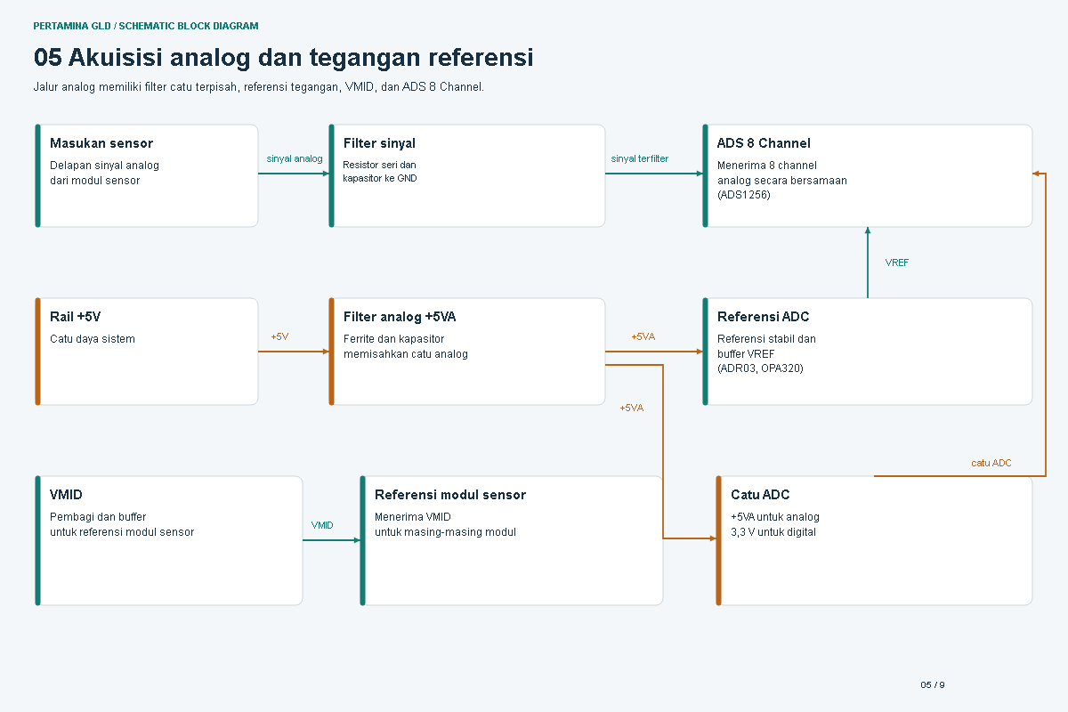
Sheet 5 of 9 — Analog acquisition
The 8-channel analog acquisition front end: analog inputs, ADC (ADS1256), reference, and VMID biasing.
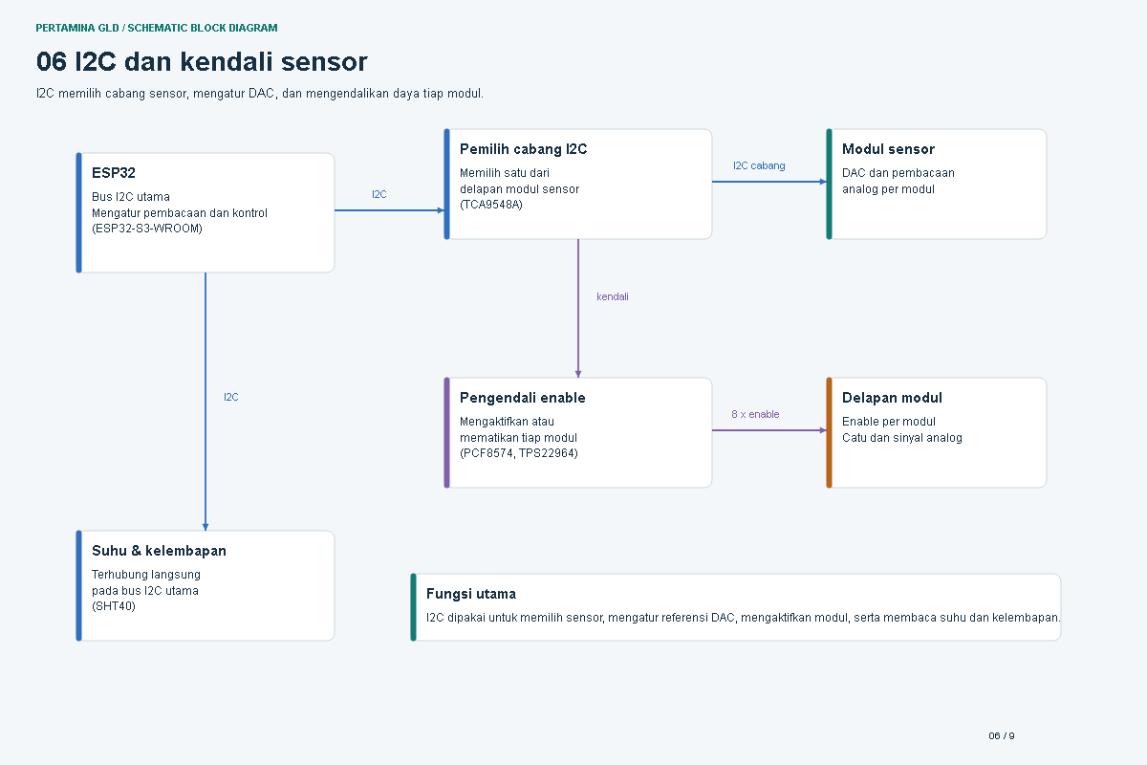
Sheet 6 of 9 — I2C & sensor control
I2C channel selection (TCA9548A), per-channel sensor enable (PCF8574), and the temperature/humidity sensor (SHT40).
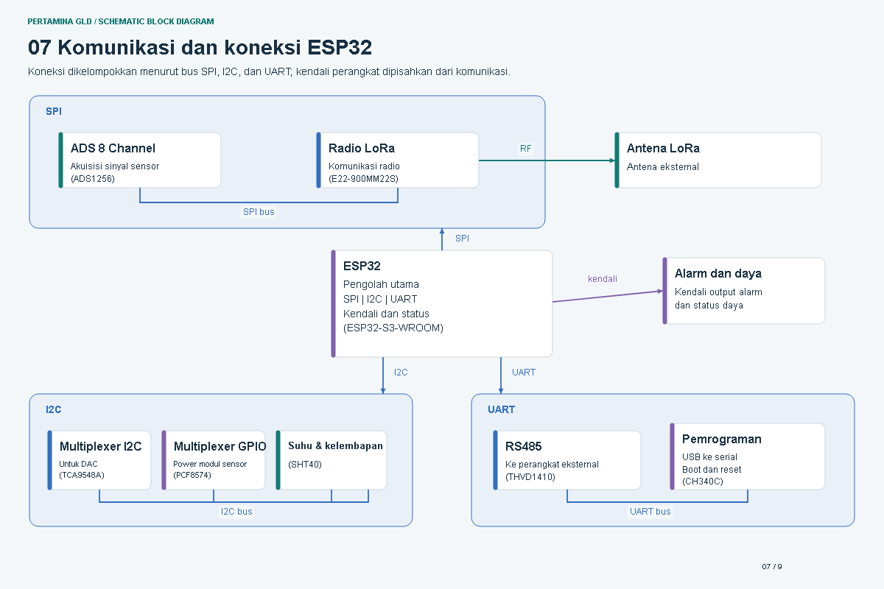
Sheet 7 of 9 — ESP32 connections
Main controller (ESP32-S3) interface map: SPI to the ADC, I2C to sensor/control, UART for USB and RS-485, and GPIO for alarm, power, button, and LED.
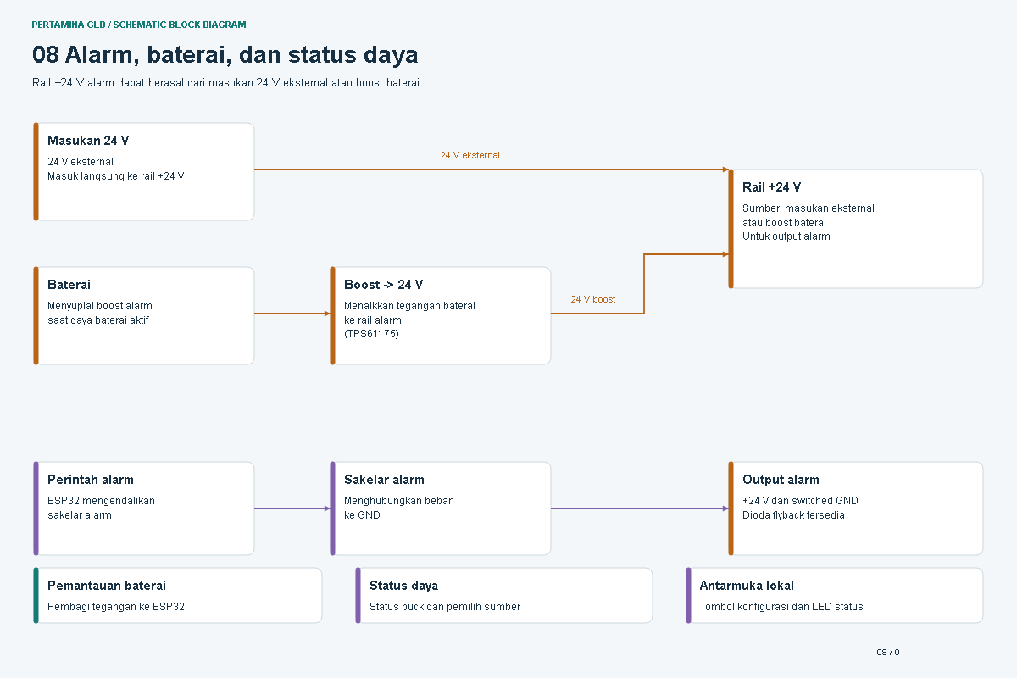
Sheet 8 of 9 — Alarm & status
Alarm output and status-indication circuitry driven from the main controller.
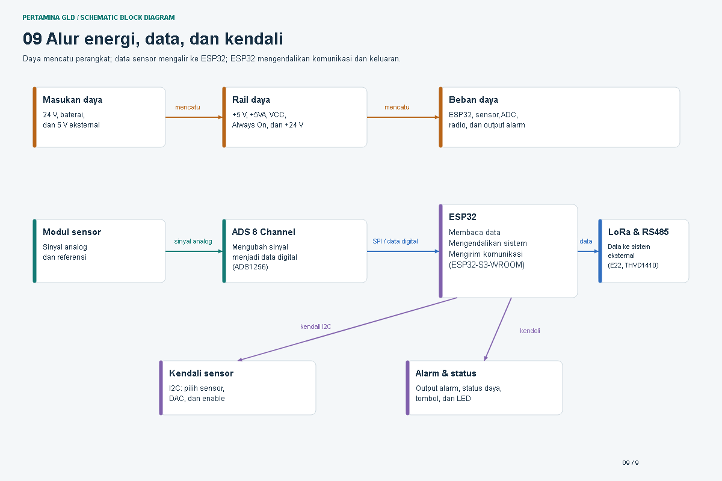
Sheet 9 of 9 — System flow
Overall signal and data flow across the board, summarizing how the preceding eight sheets connect end to end.
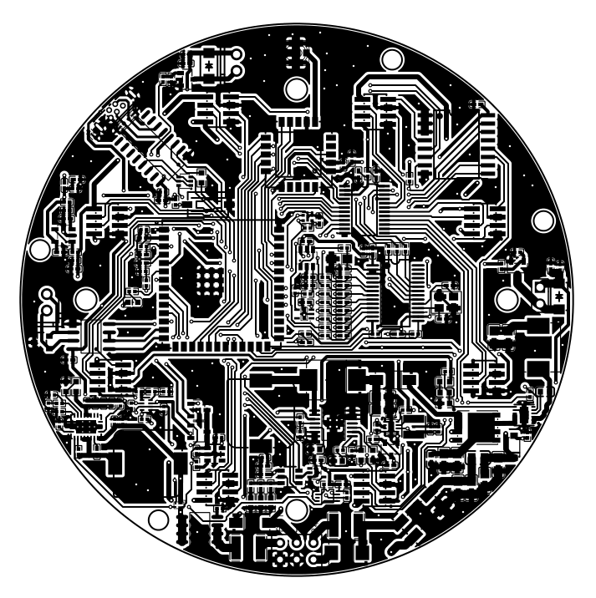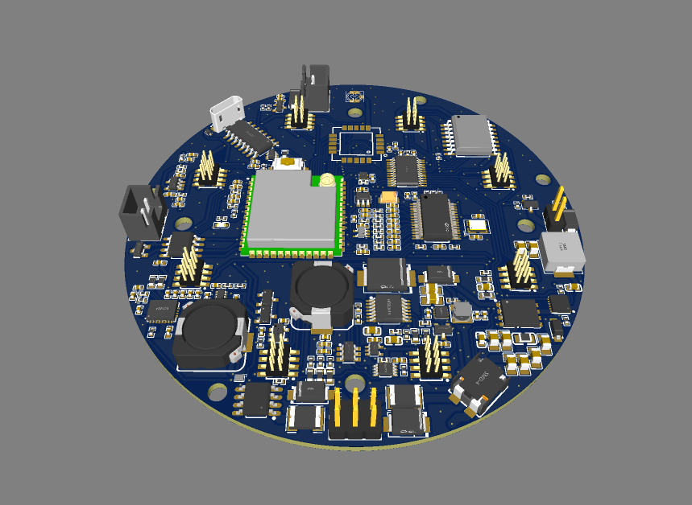
Main board PCB layout (top copper) and 3D populated render
Both exported directly from the EasyEDA/JLCPCB source project (production-intent board, circular outline with six mounting holes). The 3D render shows the ESP32-S3-WROOM module, micro-USB connector, power inductors, and 8-channel I2C header block in their real placed positions; it is an illustrative render, not a dimensioned drawing.
A dimensioned mechanical drawing sheet also exists for the enclosure's external envelope and its mounting hardware, drafted from a solid CAD model (STEP format, millimeter units) with a formal title block, orthographic and isometric views, and a parts table — reproduced below.
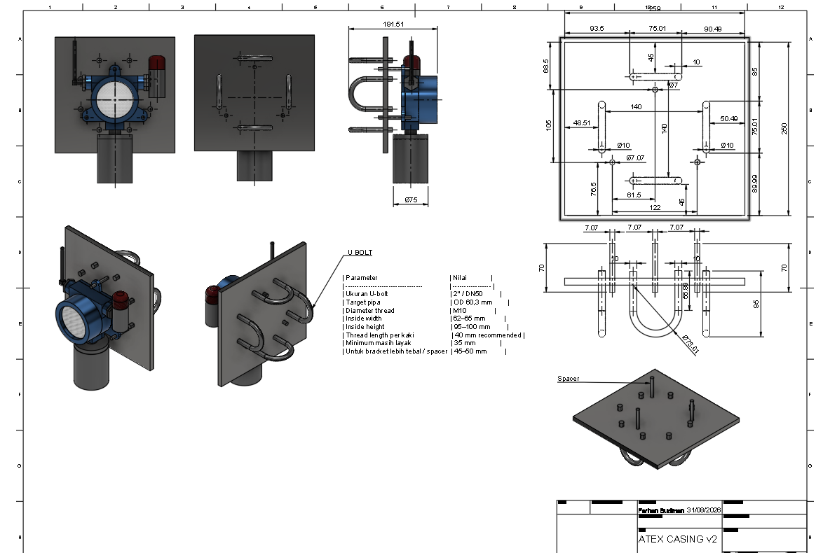
Enclosure envelope & mounting bracket — dimensioned drawing sheet
Orthographic and isometric views with real dimensions (enclosure neck Ø75 mm, overall probe height 191.51 mm, mounting plate 250×250 mm with toleranced hole pattern), a U-bolt parameter table (2″/DN50, M10 thread), and a title block (drafted 31 Aug 2026). Source: dimensioned CAD drawing derived from a STEP solid model of the enclosure and bracket assembly.
DRAWING TYPE | STATUS | REMARKS
Electrical schematic (component-level) / block diagram | Partially available | Schematic capture and a derived 9-sheet block-diagram set exist with traceability evidence (pin-to-net mapping). Not yet issued in a released, revision-controlled drawing format with a formal drawing number.
PCB layout | Partially available | Native EasyEDA/JLCPCB layout export (routed copper) and a 3D solid model exist for the same board revision. Not yet issued as a dimensioned, toleranced, released drawing with a formal drawing number.
Assembly drawing | Partially available | A dimensioned drawing sheet exists for the enclosure/bracket mounting assembly (title block, orthographic + isometric views, parts table). It covers the external envelope and mounting hardware, not the internal PCB/component assembly sequence.
Component drawing | Not yet available
Enclosure structure drawing (gap, length, volume) | Partially available | External envelope is dimensioned (from a real STEP solid model, millimeter units) in the drawing above. The Ex-d-specific flame-path parameters — joint gap, length, and free internal volume — are not called out; that dimensioning has to be added deliberately once a protection concept is confirmed (Section 2.5), not derived automatically from the CAD export.
Junction box / terminal / grounding connection drawings | Candidate reference only | A Chinese enclosure-component supplier's drawing for a die-cast “Universal Base” (part no. BP18-1Z, material ADC12, 0.6 kg, drawing scale 1:1) has been received via the casing partner's supply chain. It specifies 2× M20×1.5-6H cable-entry threads, 4× M4-6H and 1× M5×1.5-6g fixing threads, 3× Ø8 mm mounting holes, an internal bore up to Ø94.7 mm, and overall dimensions approximately 124×115×67.5 mm. Its footprint does not match GLD's main enclosure (200×90×290 mm), so this is understood as a candidate junction-box/terminal sub-component under evaluation, not yet confirmed as part of GLD's design. A dedicated grounding connection drawing has not been provided.

Real dimensioned CAD drawings now exist for the enclosure's external envelope and mounting hardware, and native PCB layout/schematic source files exist for the electronics. What is still missing for a certifiable drawing package: internal component/assembly drawings, junction box and grounding-connection drawings, and — specific to explosion protection — flame-path gap/length/volume dimensioning, which requires a confirmed protection concept before it can be drawn.

2.6.b · Bill of Materials (BOM) for Explosion-Safety-Relevant Components
A complete, itemized electronic-component BOM for both the main board and the external sensor board now exists, exported directly from the EasyEDA/JLCPCB source project (manufacturer, manufacturer part number, and LCSC supplier part number for each line item; 89 line items / 214 placed components on the main board, 14 line items / 24 placed components on the sensor board — full tables below). This is real, traceable sourcing data and materially improves on the previous status.
It does not, however, satisfy this checklist item as written. The checklist asks specifically for the explosion-safety-relevant BOM — enclosure, gaskets, terminals, cable entry devices, switches, light sources, battery, potting compound, and plastic parts, each with material grade and Ex/UL/CCC certification status. None of those mechanical/safety items appear in an electronic CAD BOM: the enclosure is present only as a placeholder mechanical symbol (designator U50, no manufacturer or dimensional data attached), and the gas sensor itself (MQ2, designator I1) has no manufacturer or supplier part number recorded — it is sourced outside the LCSC/JLCPCB supply chain and its Ex status is unverified. Comparative research on Ex-rated enclosure products from other manufacturers exists internally as a reference for target specifications only — it describes third-party products, not this product's actual components, and is not included here.
DESIGNATOR | VALUE / PART | QTY | MANUFACTURER | MANUFACTURER PART NO. | LCSC #
C1 | 1uF | 1 | SAMSUNG | CL21B105KBFNNNE | C28323
C2,C3 | 100nF | 2 | YAGEO | CC0805KRX7R9BB104 | C49678
C4,C59,C60,C10 | 10uF | 4 | muRata | GRM21BR61H106KE43L | C440198
C72,C73 | 33uF | 2 | TDK | C2012X5R1A336MTJ00E | C342635
C7 | 47nF | 1 | SAMSUNG | CL10B473KB8NNNC | C1622
C8 | 22nF | 1 | SAMSUNG | CL10B223KB8NNNC | C21122
C70 | 33pF | 1 | SAMSUNG | CL10C330JB8NNNC | C1663
C61,C69 | 100nF | 2 | YAGEO | CC0603KRX7R9BB104 | C14663
C87,C12,C13,C14,C41,C42,C43,C44,C46,C47,C48,C49,C50,C51,C52,C54,C55,C58,C65,C66,C15,C6,C19,C20,C21,C22,C23,C24,C25,C26,C27,C28,C29,C30,C31,C84,C78,C81 | 100nF | 38 | SAMSUNG | CL05B104KO5NNNC | C1525
CN3,CN1 | XH-2A-black | 2 | BOOMELE | XH-2A黑色 | C24193
D1 | SMBJ33A | 1 | RUILON | SMBJ33A | C10219
D2 | LBZT52C12T1G | 1 | LRC | LBZT52C12T1G | C12747
D3,D10 | BAT54C | 2 | CJ | BAT54C | C2135
D4,D5,D11 | LESD5D5.0CT1G_C5199850 | 3 | UMW | LESD5D5.0CT1G | C5199850
D6 | SM712 | 1 | DOWO | SM712 | C293966
D7,D13 | SS54_C22452 | 2 | MDD | SS54 | C22452
D12 | SK36_C266330 | 1 | GOOD-ARK | SK36 | C266330
F1,F2 | MINISMDC260F/16 | 2 | Littelfuse | MINISMDC260F/16-2 | C16490
G$1 | UFL | 1 | — | — | —
J1 | VIN | 1 | — | — | C65114
L1 | 300Ω | 1 | TDK | ACM7060-301-2PL-TL01 | C76580
L2 | 2.2uH | 1 | SXN | SMDRH105R-2R2NT | C10164
L3 | 2.2uH | 1 | APV | ANR3015T2R2M | C6364793
L4 | 100Ω | 1 | TDK | MPZ2012S101AT000 | C15957
L5 | 10uH | 1 | SXN | SMDRH105R-100MT | C9185
LED1 | 19-217/BHC-ZL1M2RY/3T | 1 | EVERLIGHT | 19-217/BHC-ZL1M2RY/3T | C72041
Q1 | UMH3NTN | 1 | ROHM | UMH3NTN | C123008
Q2 | AO4407_C5155210 | 1 | JSMSEMI | AO4407 | C5155210
Q3 | SI7465DP-T1-GE3 | 1 | VISHAY | SI7465DP-T1-GE3 | C499482
R3 | 187kΩ | 1 | UNI-ROYAL | 0603WAF1873T5E | C22896
R6 | 82kΩ | 1 | UNI-ROYAL | 0603WAF8202T5E | C23254
R86 | 19.1kΩ | 1 | UNI-ROYAL | 0603WAF1912T5E | C22897
R87 | 1kΩ | 1 | UNI-ROYAL | 0603WAF1001T5E | C21190
R89,R36 | 56kΩ | 2 | UNI-ROYAL | 0603WAF5602T5E | C23206
R90 | 189k | 1 | YAGEO | RT0603BRD07189KL | C861174
R92 | 33kΩ | 1 | UNI-ROYAL | 0603WAF3302T5E | C4216
R96 | 470Ω | 1 | UNI-ROYAL | 0603WAF4700T5E | C23179
SW1 | SKQYAAE010 | 1 | ALPSALPINE | SKQYAAE010 | C115352
U1 | TPS61175PWP | 1 | TI | TPS61175PWP | C2879383
U36 | LMR51450SDRRR | 1 | TI | LMR51450SDRRR | C6890985
U40 | 4.7uH | 1 | ABC | GSSM06304R7M2AU | C2928306
U41 | TPS61088RHLR | 1 | TI | TPS61088RHLR | C87357
U42 | TPS7A0233DBVR | 1 | TI | TPS7A0233DBVR | C5142805
U43 | TPS62162DSG | 1 | TI | TPS62162DSGR | C40256
U46 | TPL5010 | 1 | TI | TPL5010DDCR | C473912
U47 | THVD1410DR | 1 | TI | THVD1410DR | C2671345
U48 | CH340C | 1 | WCH | CH340C | C84681
U50 | casingAlGasLeak | 1 | — | — | —
U51 | SN74AUP1G74DCUR | 1 | TI | SN74AUP1G74DCUR | C140267
USB1 | U-D-M5DD-W-1 | 1 | 韩国韩荣 | U-D-M5DD-W-1 | C145795
C11,C53,C32,C33,C34,C35,C36,C37,C16,C17,C18,C38,C85,C79,C80 | 10uF | 15 | SAMSUNG | CL05A106MQ5NUNC | C15525
C45,C57 | 20pF | 2 | FH | 0402CG200J500NT | C1554
C56 | 22uF | 1 | Kyocera AVX | TAJA226M010RNJ | C7183
R8,R9,R10,R74 | 22Ω | 4 | UNI-ROYAL | 0402WGF220JTCE | C25092
R11,R65,R66,R67,R68,R69,R70,R71,R72 | 49.9Ω | 9 | FH | RC-02K49R9FT | C140147
R73,R75,R77,R2,R15,R16,R17,R18,R19,R20,R21,R22,R7,R28,R29 | 10kΩ | 15 | UNI-ROYAL | 0402WGF1002TCE | C25744
R76,R5,R31 | 1kΩ | 3 | UNI-ROYAL | 0402WGF1001TCE | C11702
U2,U3 | OPA320AIDBVR | 2 | TI | OPA320AIDBVR | C92494
U33 | TCA9548APWR | 1 | TI | TCA9548APWR | C130026
U35 | ADS1256IDBR | 1 | TI | ADS1256IDBR | C28186
U38 | ADR03AKSZ-REEL7 | 1 | ADI | ADR03AKSZ-REEL7 | C206683
U39 | 8MHz | 1 | JYJE | 3TJ480000NYLBC | C2924618
U44 | SHT40-AD1B-R2 | 1 | Sensirion | SHT40-AD1B-R2 | C2909890
U45 | E22-900MM22S | 1 | EBYTE | E22-900MM22S | C5333985
U49 | ESP32-S3-WROOM-1U-N16R8 | 1 | ESPRESSIF | ESP32-S3-WROOM-1U-N16R8 | C3013946
U12 | PCF8574T/TR | 1 | HGSEMI | PCF8574T/TR | C2987288
R13 | 16kΩ | 1 | UNI-ROYAL | 0402WGF1602TCE | C25759
R14 | 4.99kΩ | 1 | YAGEO | RC0402FR-074K99L | C137965
U13 | TPS2116DRLR | 1 | TI | TPS2116DRLR | C3235557
U14 | TPS22964CYZPR | 1 | TI | TPS22964CYZPR | C431579
U15 | SN74LVC1G06DCKR | 1 | TI | SN74LVC1G06DCKR | C7828
U16 | TPS3839K33DBZR | 1 | TI | TPS3839K33DBZR | C96333
C9 | 22uF | 1 | TDK | C2012X5R1V226MT000E | C338080
R23,R24,R25,R1,R26,R27,R4,R30,R12,R40,R41,R43 | 100kΩ | 12 | UNI-ROYAL | 0402WGF1003TCE | C25741
R32 | 200kΩ | 1 | UNI-ROYAL | 0402WGF2003TCE | C25764
C39,C40,C62,C63,C64,C67,C68,C5 | 22uF | 8 | TAIYO YUDEN | JDK105CBJ226MV-F | C385994
C71 | 1uF | 1 | SAMSUNG | CL05A105KA5NQNC | C52923
R33,R37,R38,R39 | 0Ω | 4 | UNI-ROYAL | 0402WGF0000TCE | C17168
C74 | 2.2uF | 1 | SAMSUNG | CL05A225MQ5NSNC | C12530
C75,C76 | 47nF | 2 | FH | 0402B473K500NT | C82219
R34 | 255kΩ | 1 | YAGEO | AC0402DR-07255KL | C226702
R35 | 43kΩ | 1 | UNI-ROYAL | 0603WAF4302T5E | C23172
C77 | 4.7nF | 1 | FH | 0402B472K500NT | C1538
D8,D9 | SS14 | 2 | MDD | SS14 | C2480
J2 | ALARM | 1 | — | — | C124375
Q4,Q5 | AO3400A | 2 | AOS | AO3400A | C20917
R94,R42 | 100Ω | 2 | UNI-ROYAL | 0402WGF1000TCE | C25076
H2,H1,H3,H4,H5,H6,H7,H8 | X1321WVS-2X04J-C40D53 | 8 | XKB Connection | X1321WVS-2x04J-C40D53 | C2881909
L6 | 60Ω | 1 | Sunlord | GZ1005D600TF | C23478

External sensor board (gas-sensing front end):
DESIGNATOR | VALUE / PART | QTY | MANUFACTURER | MANUFACTURER PART NO. | LCSC #
H1 | X1321FVS-2X04-C43D48 | 1 | XKB Connection | X1321FVS-2x04-C43D48 | C2684732
R9 | 1kΩ | 1 | UNI-ROYAL | 0402WGF1001TCE | C11702
U5 | TPS22919DCKR | 1 | TI | TPS22919DCKR | C2149796
I1 | MQ2 | 1 | — | MQ2 | —
C7,C8 | 10uF | 2 | SAMSUNG | CL05A106MQ5NUNC | C15525
L1 | 60Ω | 1 | Sunlord | GZ1005D600TF | C23478
R1 | 10MΩ | 1 | UNI-ROYAL | 0402WGJ0106TCE | C26086
R2,R3 | 10kΩ | 2 | UNI-ROYAL | 0402WGF1002TCE | C25744
R7,R8 | 20kΩ | 2 | UNI-ROYAL | 0402WGF2002TCE | C25765
C1,C2,C3,C4,C5,C6 | 100nF | 6 | SAMSUNG | CL05B104KO5NNNC | C1525
R4,R5,R6 | 49.9Ω | 3 | FH | RC-02K49R9FT | C140147
U1 | INA333AIDGKR | 1 | TI | INA333AIDGKR | C19450
U2 | LM321DTR(XBLW) | 1 | XBLW | LM321DTR(XBLW) | C18723612
U3 | MCP4725A0T-E/CH | 1 | MICROCHIP | MCP4725A0T-E/CH | C144198

Status: Partially available. Full electronic-component BOM with real manufacturer/supplier data now exists (source: EasyEDA/JLCPCB export, 11 Sep 2026). The explosion-safety-relevant subset the checklist actually asks for — enclosure, gasket, cable entry device, battery, potting compound, and the gas sensor itself, with material grade and Ex/UL/CCC certification for each — remains not yet compiled. These are mechanical/safety parts, not electronic components: the enclosure itself is under design by an external mechanical/casing development partner (legal identity now confirmed as PT Galaksi Megatama Indonesia — see Section 1.4) and its bill of materials has not yet been provided to the authors.

2.6.c · Material Specification Sheets / Datasheets (Non-Metallic Materials)
Datasheets or supplier conformity declarations for non-metallic materials (enclosure components, seals, insulators, potting compounds) — covering heat/cold resistance, anti-aging, anti-static, flame retardancy, CTI value, and chemical resistance — have not yet been collected.
Per IEC 60079-0:2017, once GLD's specific non-metallic components are identified the applicable requirements are: a Comparative Tracking Index (CTI) class per Table 5/6 appropriate to the equipment's creepage/clearance design; a glow-wire or needle-flame flame-retardancy result per §26.4–26.5; a glass-transition temperature (Tg) safely outside the confirmed −20°C to +60°C ambient operating range (Section 2.3.c); and UV/weathering-resistance data for any component exposed outdoors. These thresholds are cited from the standard itself and have not yet been matched against actual component datasheets.
Non-metallic components in the design that this item will need to cover: the cover-to-body sealing gasket providing the IP66 rating (Section 2.3.c — identified as a rubber gasket in the casing partner's assembly drawing, specific compound/grade not yet specified); the integral seal of the candidate M20×1.5 cable gland — per project direction, specified together with the gland itself from the BP18-1Z reference (Section 2.3.c), rather than as a separately sourced component; and the antenna/SMA feedthrough insulator (material not yet specified). The protective mesh cover over the gas-sensing element is now identified as a stainless-steel wire mesh in the same assembly drawing — being metallic, it falls outside this specific non-metallic-materials checklist item.
Status: Not yet available. Dependent on the enclosure design and material selection, which sits with the external casing development partner (PT Galaksi Megatama Indonesia, Section 1.4) rather than the authors; this data has been formally requested from that partner. Partial candidate data: the BP18-1Z reference drawing (Section 2.6.a) specifies a powder-coating surface treatment with two electrostatic-safety parameters directly relevant to this checklist item — maximum surface charge transfer <10 nC and maximum surface capacitance <5 pF (coating thickness ≤ 0.2 mm). These are the type of parameter IEC 60079-0 requires for coated/non-metallic surfaces on Ex equipment, but they describe a supplier's candidate component, not a confirmed datasheet for GLD's own enclosure finish.

2.6.d · Manufacturing Process Description
A description of manufacturing processes relevant to explosion-protection safety (enclosure machining accuracy control, explosion-proof surface treatment, welding, potting, die-casting, bonding) has not yet been documented.
Status: Not yet available. This describes the casing partner's (PT Galaksi Megatama Indonesia) manufacturing process, not an internal electronics process — it will need to be obtained from that partner once their process is finalized.

2.6.e · Explosion-Protection Calculations and Explanations (if applicable)
Flame-path (joint gap, length) and free-internal-volume calculations specific to Ex d (Section 2.5, team recommendation) have not yet been performed, pending final enclosure geometry from the casing development partner and a confirmed protection concept with the ExCB.
Status: Not yet available — pending ExCB confirmation of the Ex d protection concept and final enclosure design.

2.6.f · Temperature Group Calculation (Hottest-Point Temperature Estimation)
No hottest-point temperature calculation or measurement has been performed for this product. As general context: MQ-series metal-oxide gas sensors operate using an internal heating element, a class of sensor commonly associated with published operating temperatures in the approximate 200–400°C range — however, this is a general characteristic of the sensor class, not a measured value for the specific sensor models, drive circuitry, and enclosure configuration used in this product. A worst-case hot-spot measurement is identified as the top-priority action required to substantiate the recommended T4 classification in Section 2.5.
Status: Not yet available.

2.6.g · Usage and Installation Instructions (Draft)
SUB-ITEM | STATUS | REMARKS
a) Safety warnings | Draft available | Drafted below (18 Sep 2026); not yet reviewed against a selected explosion-protection concept.
b) Installation requirements (cable entry, torque, grounding, cleaning) | Draft available | Procedural text drafted below; the mechanical mounting method itself (U-bolt mounting plate, no drilling/welding — Section 2.3.c) and the specific cable gland/torque values are still pending final component selection.
c) Operating instructions and maintenance requirements | Draft available | Drafted below, alongside a firmware command/operation reference (Serial, MQTT, LoRa protocol) used for engineering commissioning. Ex-specific maintenance frequency/content is not yet defined pending protection-concept selection.

Status: Draft text available (source: internal working draft, Rev. 18 Sep 2026). This is a draft for review, not a finalized, Ex-approved installation and operation manual. It has not been checked against a selected type of protection (Ex d/e/i, Section 2.6.e), a confirmed temperature class (Section 2.6.f), or finalized cable-entry/enclosure hardware. It also feeds the standalone Instruction_Manual_GLD deliverable.

2.6.g.a · Safety Warnings (Draft)
- Only trained and authorized personnel may install, commission, operate, inspect, or maintain the detector.
- Isolate and verify the 24 VDC supply before opening the enclosure or changing wiring. Apply the site lockout/tagout procedure.
- Use only the approved production power arrangement: 24 VDC.
- Perform alarm tests with appropriate site controls and hearing protection where audible devices are connected.
- Perform sensor nulling only in confirmed clean air. Accept the operation only when all eight sensors report a complete 8/8 result; otherwise correct the cause and repeat.
- Do not drill, weld, enlarge cable entries, bypass protective devices, or modify the enclosure without written engineering and Ex approval.
- Remove the unit from service if there is visible damage, water ingress, an unresolved sensor fault, failed alarm proof, or a loss of protective-earth continuity.
2.6.g.b · Detailed Installation Requirements (Draft)
Cable entry method: Use only cable glands, adaptors, blanking elements, and seals approved for the final protection concept, certificate, thread form, IP rating, cable outer diameter, and installation temperature. Do not create new entries, enlarge an entry, leave unused entries open, or substitute a general-purpose gland. Maintain the manufacturer sealing and clamping sequence. Record the installed component part number and certificate reference.
Torque requirements: Torque values shall comply with the approved enclosure, terminal, cable-gland, and blanking-plug manufacturer instructions. (Specific torque figures are not yet available — dependent on final hardware selection.)
Grounding requirements: Connect the enclosure to the approved protective-earth system using the designated grounding terminal. Verify continuity before energization.
Cleaning requirements: For routine cleaning, isolate the equipment as required by site procedure and use a soft lint-free cloth lightly dampened with clean water or an approved mild cleaner. Do not use abrasives, aggressive solvents, dry compressed air, high-pressure spray, or tools that can damage the enclosure, gasket, label, antenna, or cable entries. Keep liquid out of all openings.
2.6.g.c · Operating Instructions and Maintenance Requirements (Draft)
Before each operating period, check power, enclosure condition, diagnostic status, communication status, and the absence of active faults. Treat an alarm as a real process-safety event until the site response procedure establishes otherwise. If the detector reports a fault or loses required communication, notify the responsible operator and place the affected detection point in the site impairment process. Do not change firmware, model files, alarm thresholds, or calibration parameters from the field without controlled approval and a documented rollback path.
Three operating modes are distinguished:
MODE | PURPOSE | USE RESTRICTION
Inference | Normal gas-class inference and alarm operation | Production operating mode after commissioning
Dataset | Engineering / data-collection activity | Not a substitute for approved detection operation
Nulling | Sensor baseline / calibration activity | Clean air only; perform under approved procedure; require complete 8/8 result

2.6.h · Nameplate Information
Nameplate artwork cannot yet be finalized: it depends on the certificate number, protection marking, temperature class, ambient range, IP rating, and serialization scheme — none of which has been assigned yet.
Status: Not yet available.

2.6.i · Ex Component Certificates
No components in this design currently hold an Ex component certificate. As noted in Section 2.3.b, the processing unit (ESP32-S3-WROOM-1U-N16R8) and the communication module (E22-900MM22S) hold RF/EMC certifications (FCC, TELEC, CE, RoHS) — these are not Ex component certificates and do not satisfy this item.
Status: Not yet available.

3. Sample Information
Model, serial number, and sample status (whether the unit can be powered on and operated), together with any required test fixtures or auxiliary equipment.

3.1 · Model, Serial Number, and Status
No formal sample register or dossier for ExCB submission has been established. Internal engineering and bench testing reference the “GLD V2” board configuration under firmware environment gld_v2; a discrete unit serial-numbering scheme for certification samples has not yet been implemented.
Status: Not yet available. The product is still being built from scratch at prototype/development stage; no finalized, serialized unit yet exists to register as a submission sample. This item becomes actionable once a build reaches a stable, submission-ready configuration.

3.2 · Test Fixtures and Auxiliary Equipment
A draft internal functional test plan identifies the minimum equipment anticipated for bench-level verification (this plan has not yet been executed and is not evidence of lab readiness):
TEST GROUP | MINIMUM EQUIPMENT
Firmware / serial | Engineering commissioning tool or serial terminal; firmware package with recorded version
I2C / ADC / DAC | No additional equipment for protocol-level acknowledgement/readback; multimeter or oscilloscope where physical voltage must be substantiated
Power / watchdog timer | Controlled 24 V supply, an applicable battery source, multimeter, and oscilloscope/logic analyzer
Alarm | The actual alarm load, multimeter/oscilloscope, and hearing protection if an audible buzzer is fitted
LoRa | At least one counterpart Cluster Head/Gateway device with recorded configuration
RS-485 / Modbus | An RS-485/USB-RS485 master with proper termination and the agreed register map

Status: Draft plan only — not yet executed, and not evidence of ExCB/laboratory test readiness.

A second, commissioning-oriented equipment list is drafted separately (source: internal working draft, Rev. 18 Sep 2026), organized by physical test apparatus rather than by test group:
EQUIPMENT | PURPOSE
Regulated 24 VDC power supply | Provides a stable 24 VDC supply to the GLD during commissioning and functional testing.
Digital multimeter | Measures the actual voltage, verifies polarity and continuity, and supports grounding/bonding verification.
Calibrated gas source / gas test kit | Provides the required gas types to verify that the sensors respond correctly when exposed to the target gases.
Gas test chamber | Provides a controlled gas-exposure environment so that gas concentration, exposure time, and test conditions can be reproduced.
Alarm load / relay simulator | Physically verifies that the alarm output and connected electrical load operate correctly.
LoRa peer / gateway | Verifies that data transmitted by the GLD is successfully received by the intended system.
Laptop and approved software | Used to review diagnostic information, configuration, logging, firmware identification, and to store commissioning and test evidence.
Calibrated torque screwdriver | Ensures that glands, terminals, enclosure fasteners, and grounding connections are tightened to the approved torque values.

This is a working document, prepared in stages, drafted in direct reference to the IECEx/ATEX Certification Information Requirements (original English/Mandarin version issued by the certification body). Data sources: the official product technical datasheet (Institute of Technology Bandung, Revision 4.0), internal technical specification documentation, EMC parameter measurement data, and product photography. Fields marked “Pending confirmation” are not yet final and must not be relied upon for procurement or certification purposes without further verification.

